February
2020
6th Grade Health
Mr. Mendelson & Ms. Jeffries | 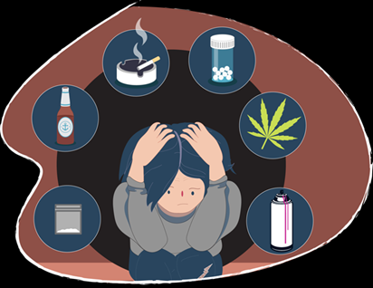
Sunday | Monday | Tuesday | Wednesday | Thursday | Friday | Saturday
 |  |  |  |  |  | 1
2 | 3 | 4 | 5 | 6 | 7 | 8
 | No School | Work on Nutrition Project | Fooducate Activity | School Lunches assignment | Yesterday’s Food Diary  Eat this not that
9 | 10 | 11 | 12 | 13 | 14 | 15
 | Test Review  Gimkit | Nutrition Test | What are drugs?  Medicine Mystery | Straight at Ya Video | Peer Pressure  Scenarios
16 | 17 | 18 | 19 | 20 | 21 | 22
 | No School | Alcohol Pre-Test  Alcohol Notes  Serving Size | Alcohol and The Brain (asklistenlearn) | Tobacco Pre-Test  Tobacco Notes  Biofeedback Video | The Real Cost Webquest
23 | 24 | 25 | 26 | 27 | 28 | 29
 | Marijuana Facts vs Opinions  Marijuana Notes  Breaking down the Myth | Just the Facts  Whats wrond with inhalants video/notes | Alcohol and Drug Free teen Video  Begin Public Service Announcement Project | Work and Finish PSA Project | Test Review for Test 3
View and edit this document in Word on your computer, tablet, or phone. You can edit text; easily insert content such as pictures, shapes, and tables; and seamlessly save the document to the cloud from Word on your Windows, Mac, Android, or iOS device.

